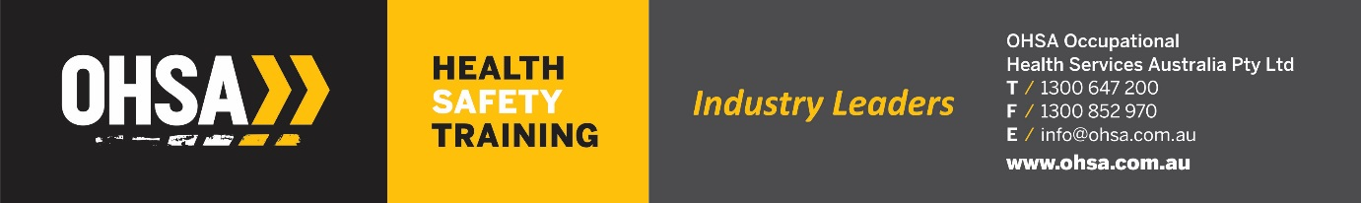

**ICAM Lead Investigator Course**

**Forktruck Incident – Monday 8th June 2020**

***(not an actual event – created for training purposes only!)***

**Incident Description**

A delivery truck was making a delivery of goods to the inbound work area at the Richlands Depot on Monday, June 8th 2020 6.55am. On arrival the driver Mr Rex Thump was told there would be a substantial wait due to a shift change over. The delivery driver asked if they could unload his truck, as he was on a time schedule as well.

The driver approached the first forklift operator he saw, Mr David Roberts, a T&T casual employee fork truck operator and asked if he could unload his truck to the time schedule he was on. The forklift operator said he would find a forklift to unload the truck. The operator returned with the CAT Order Picker which had 11000 hrs on it.

The truck was parked just outside the loading bay, due to the backlog to trucks. This was a common occurrence within the facility and a known practise, which does not conform to the traffic management plan. The area had a gradient of 4 degrees facing downhill towards the truck. The truck driver handed the delivery docket over to the driver stating the weight of the pallets. Each pallet weighed 1,500kg.

The operator lifted the first pallet and drove backwards up the incline with the load still raised in the air. Once the high reach truck got to the top of the incline the operator applied his brakes to stop the machine as he felt hot liquid spraying towards him. In doing so the machine fell forwards, raising the rear of the machine off the ground and the suspended load crashed into the ground in front of him hitting the driver of the truck and causing him 2 fractured ribs, fractures to both lower legs and a fracture to his T6 vertebrae.

The operator was thrown from the cabin onto the ground. First aid was applied to the truck driver until emergency services turned up. On inspecting the high reach truck, a hydraulic hose had blown due to the bulge in the hose. A logbook was found on the machine and the last entry was over 6 months ago.

Today is Monday 8th June 2020.

**Forklift**

**Make:** Three Wheel Electric Counterbalance

**Manufacture:** Toyota TMH 7FBE18 with a 3 stage 6500mm mast

**Attachments:** Sideshift

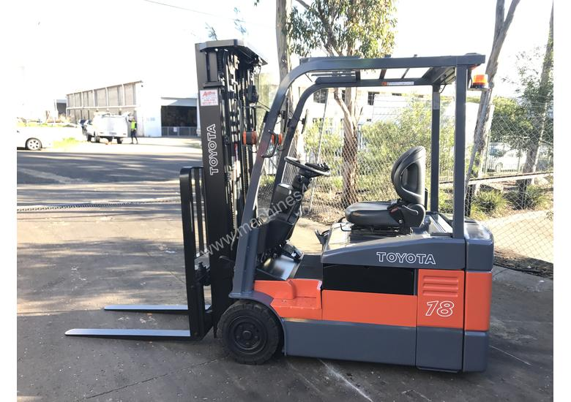

**Make:** CAT Order Picker

**Manufacturer: CAT**

**Capacity:** 1451Kg

[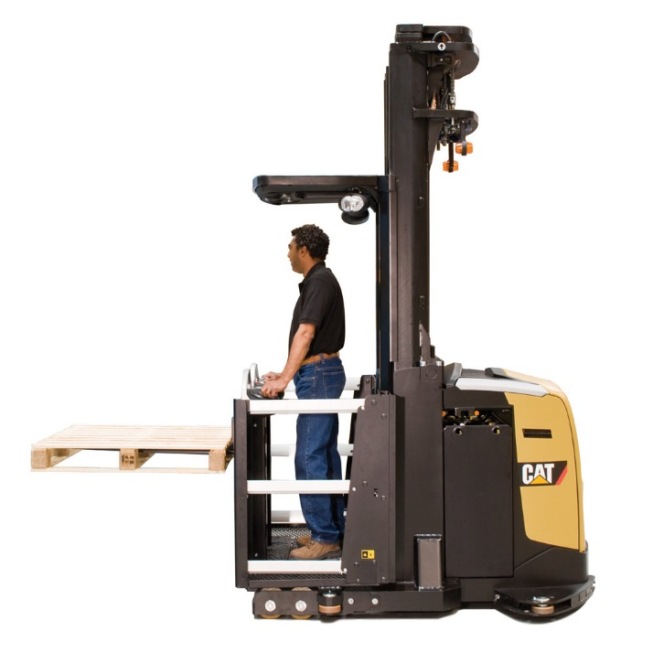](https://www.unitedequipment.com.au/wp-content/uploads/2016/01/Cat-Order-Picker-NOH10NH-2.jpg)