SHORT COURSES and HIGHER QUALIFICATIONS-

(a) Documentation recording the eligibility of all Participants under the Program:

(i) One (1) of the following:

a. Full Birth Certificate or Birth Certificate Extract (commemorative birth certificate cannot be accepted) or;
b. Passport (up to 6 months expiry) or;
c. Current Medicare card (green only) or My.Gov Medicare Snapshot; or
d. Visa holder with permission to work (as per Schedule 3 – Participant Eligibility) or;
e. Permanent resident of Australia - Certificate of Evidence of Residence Status (CERS)

AND

(ii) One (1) of the following:

a. Queensland Driver License; or
b. Telephone account; or
c. Bank statement; or
d. Statement from a real estate agent; or
e. Any other formal documentation stating the Participant's full name and current residential address; and

AND

(b) If an eligible Participant under Short Courses and Higher Qualifications:

(i) Evidence to verify Participants meet the Eligible Worker or Unemployed Eligible Worker criteria:
Evidence provided may include but is not limited to the following:

a. QLeave Statement (current statement showing credits within last 4 years) OR
b. Relevant current Licence (as per listing)* OR
c. Employer letter (on letter head and signed by the employer) confirming employment, role and duties in the Building and Construction industry OR
d. Statutory Declaration providing details of employment including role and duties within the Building and Construction Industry OR
e. ABN/ACN registration showing ownership and Invoices for recent work in the industry (Self Employed Only)
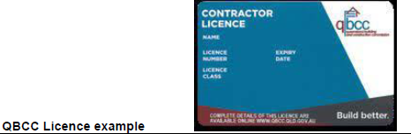

(iii) or in addition to (i), if an Unemployed Eligible Worker, evidence that demonstrates unemployment for a period less than 4 years and must be verified by way of either:
- QLeave Statement (current statement showing credits within last 4 years) OR
- Relevant current Licence (as per listing)* OR
- Separation Certificate OR
- Statutory Declaration providing details of relevant employment including role and duties within the Building and Construction Industry.

