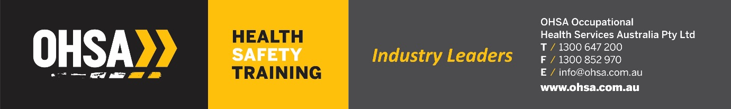

**ICAM Lead Investigator Course**

**Fork truck Incident – Monday 8th June 2020**

***(not an actual event – created for training purposes only!)***

**Your Character:**

**T&T Site Manager / WHS Advisor / HSR**

1. Today is Monday 8th June 2020 at 9am.
2. You are part of the ICAM incident investigation team.
3. You are now interviewing the Fork Truck Operator Mr. David Roberts your casual employee.
4. You will need to draw on all the information you have covered throughout the course and use any relevant documentation of T&T, Worksafe, Manufacturer’s Manuals and any other relevant sources of data.
5. Obviously you would have collected a lot of data prior to interviewing the operator, however for the sake of the role play, this is the only data you have to date.

**Information you know:**

A delivery truck was making a delivery of goods to the inbound work area at the T&T Richlands Depot on Monday, June 8th 2020 6.55am. On arrival the driver Mr Rex Thump was told there would be a substantial wait due to a shift change over. The delivery driver asked a casual fork truck operator for T&T, Mr. David Roberts, if he could unload his truck, as he was on a time schedule as well. The operator returned with the CAT Order Picker Fork Truck which had 11000 hrs on it. The operator lifted the first pallet and whilst reversing, the load fell off the fork truck tyres and injured the truck driver who was standing nearby causing him 2 fractured ribs, fractures to both lower legs and a fracture to his T6 vertebrae. First aid was applied to the truck driver until emergency services turned up. On inspecting the Fork Truck, a hydraulic hose had blown possibly due to the bulge in the hose. A logbook was found on the machine and the last entry was over 6 months ago.